**(Database)Lab 2**

1. **SELECT * FROM dept;**

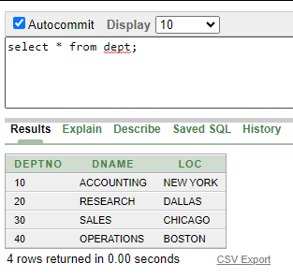

**2.** **SELECT deptno, loc FROM dept;**

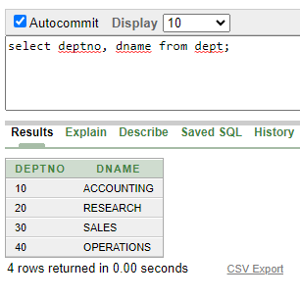

**3.SELECT ename, sal, sal+1500 FROM emp;**

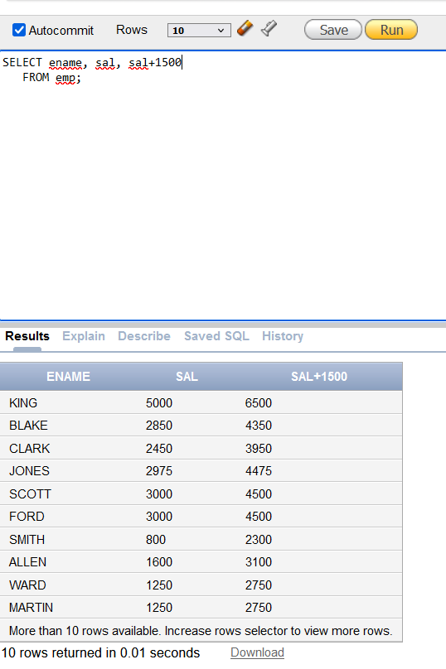

**4. SELECT ename, sal, 12*sal+100 FROM emp;**

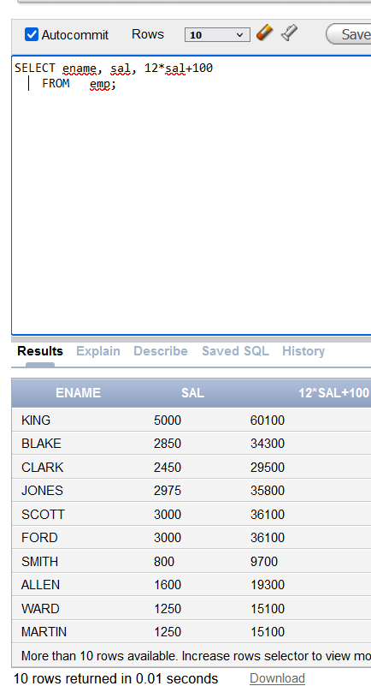

**5.** **SELECT ename, sal, 12*(sal+100) FROM emp;**

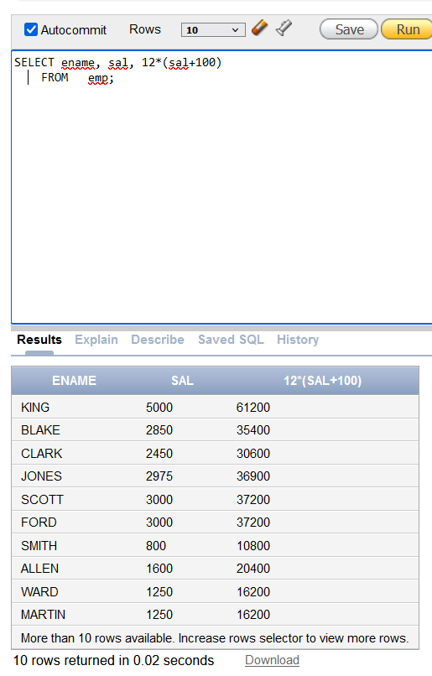

**6.SELECT ename, job, comm FROM emp;**

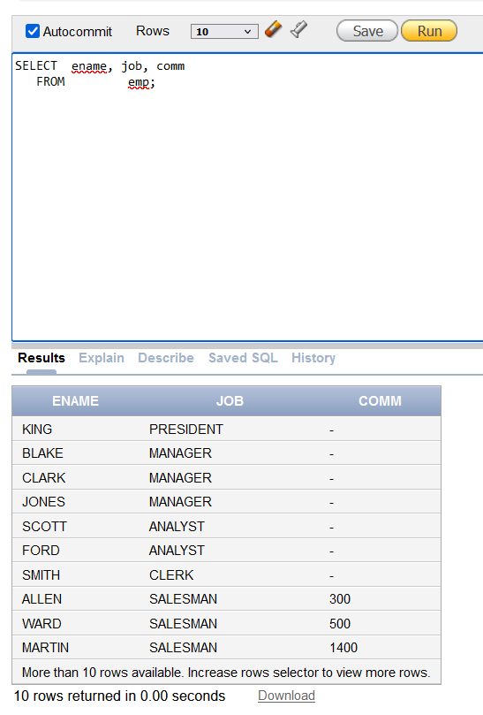

**7.** **select ename, 12*sal+comm from emp**

**WHERE ename='KING';**

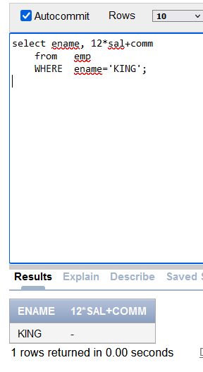

**8.** **SELECT ename "Name", sal*12 "Annual Salary"**

**FROM emp;**

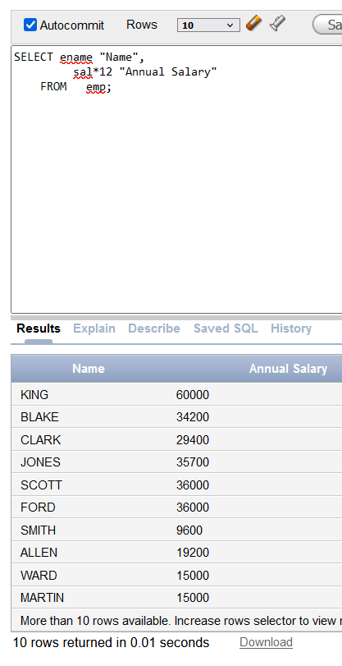

**9.** **DESCRIBE dept**

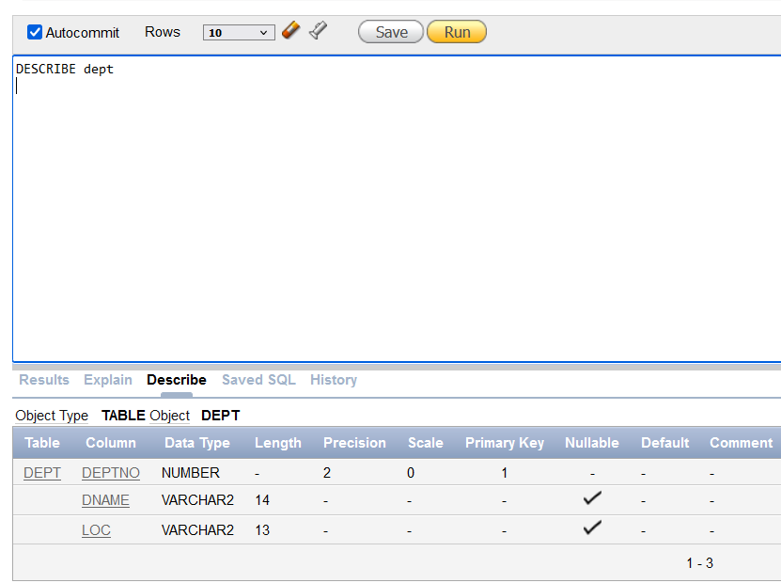

10. SELECT ename||job AS "Employees"

FROM emp;

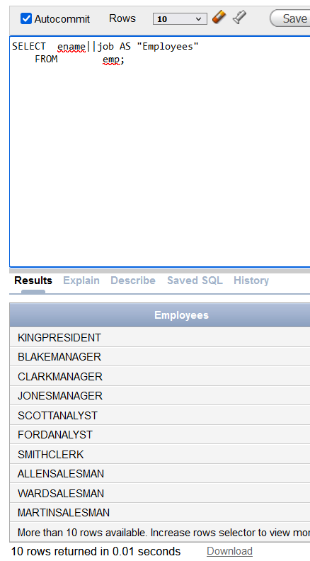

**11.** **SELECT ename ||' '||'is a'||' '||job**

**AS "Employee Details"**

**FROM emp;**

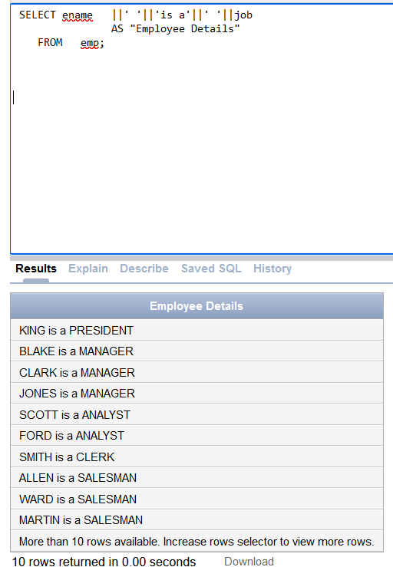

**12. SELECT deptno FROM emp;**

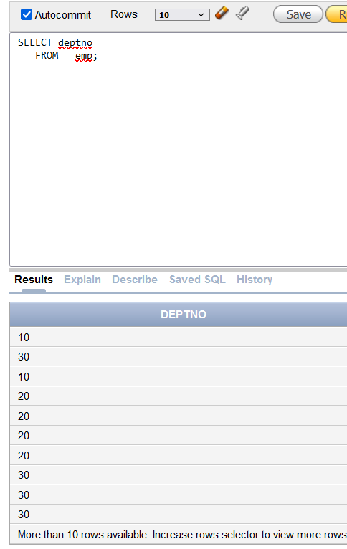

**13.** **SELECT DISTINCT deptno FROM emp;**

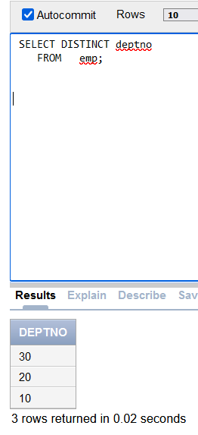

**Lab Task 1**

**1.** **SELECT ENAME "Name", DEPTNO "Department Number" from emp;**

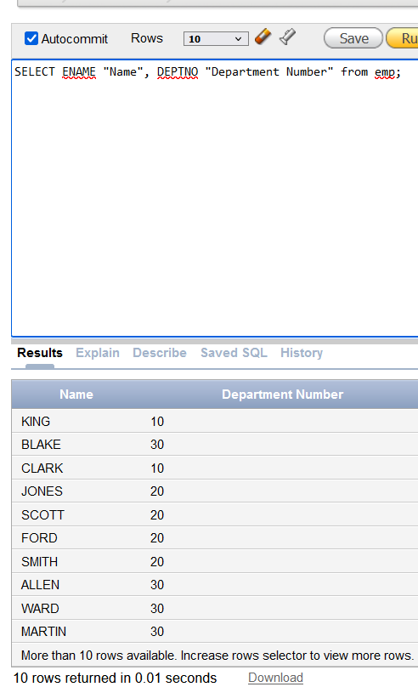

1. **SELECT JOB from emp where DEPTNO = '30';**

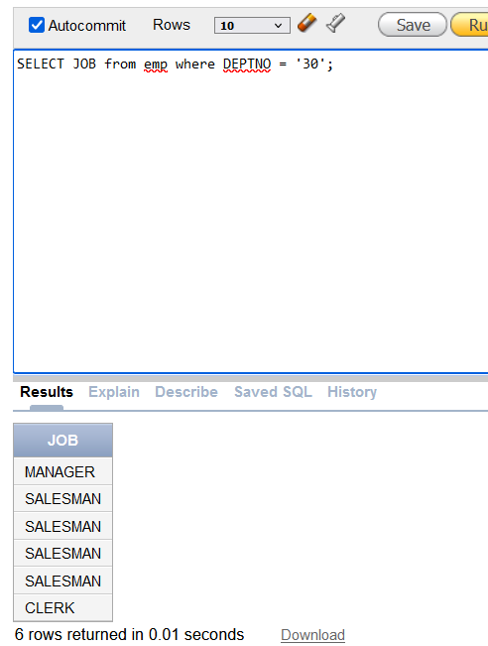

**3.** **SELECT dname as name, loc as location from dept where DEPTNO = '30';**

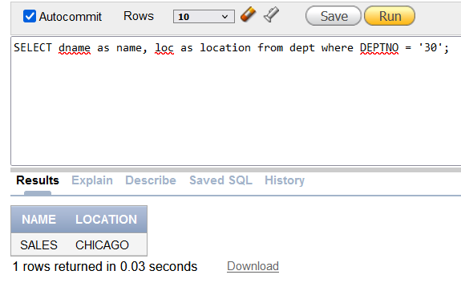

**4.** **SELECT ENAME "Name", DEPTNO "Department No" from emp where COMM > '0';**

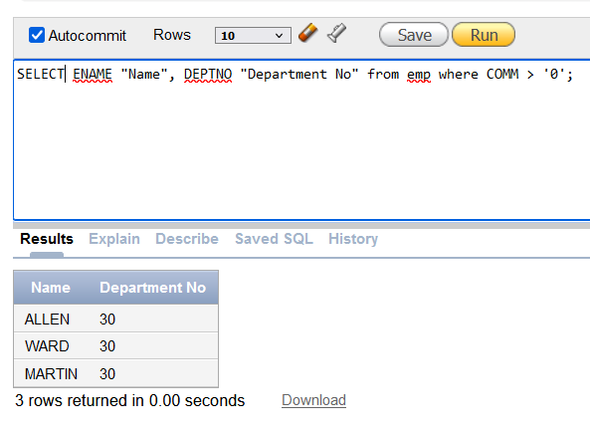



**5.** **SELECT ENAME "Name", DEPTNO "Department No" from emp where ENAME Like 'A%';**

